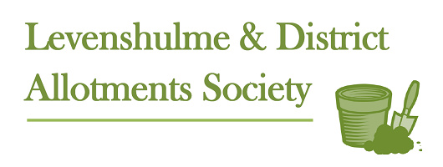

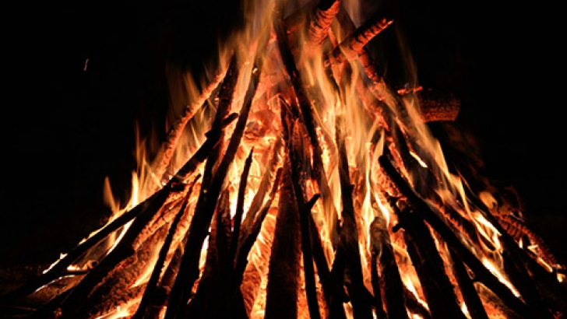
BONFIRE NIGHT
Saturday 4th November
Starts at 5pm
Bring your own fireworks, food and drink.
A veggie chilli and a hot pot will be provided
- ALL WELCOME -
Plot-holders please note: We need wood for the fire and the pond site will be
open on Saturday 21st and Sunday 22nd October between 10.00am and 2.00pm and again the following week-end for dropping off wood.
No Green waste or any rubbish will be accepted
All people attending are responsible for their own / children’s safety.
The Society is not responsible for any mishaps / accidents

